Git guide

By Eliska Vrzalova

Git init

Git initialize a new empty repository, we are now on the master branch.

After we do git init command .git folder is created in the folder where we have initialized our repository.

We can initialize our repository on local machine (this case) or we cand initialize our repository through GitHub

Repository can be initialized (using command git init) only once, if we initialized our repository through GitHub and want to start in on desktop on local machine, we need to use git clone and paste the URL of our repository from GitHub

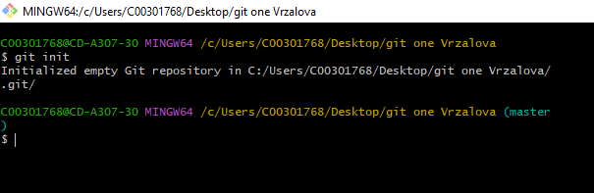

Git add

Git add command adds files in the working directory to the stages area.

If we have added .gitignore file git add command excluded those files that match lines from .gitignore file

Git add . – adds all the files

Git add filename (for ex. git guide txt.txt) – adds only the file we stated in the command.

If I modify my file after I added it – I should add them again and git will ignore the previous version of that file

In the screen shots I did git status first so I can see which files are not tracked by git (red color).

After I added the files and did git status again I was able to see that the file are now tracked and Git knows about them (green color).

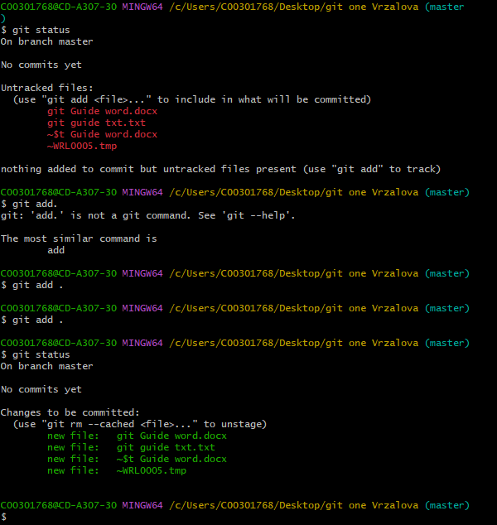

Git status

Command gist status lists files.

It shows me whether the files are modified, untracked, added

It list files on the branch we are on at the moment (master in this case)

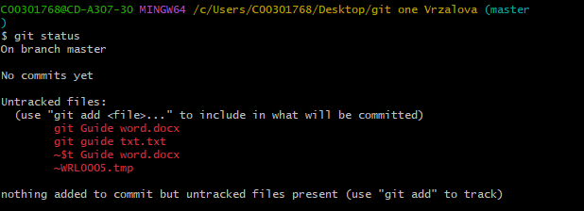If git status shows me untracked files and I want hem to be tracked, I use git add command

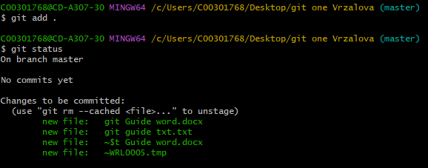

Git commit

Git commit command creates a new revision point on local repository. It is saving changes

It creates a snapshot of the staged changes – for example in the screenshot I can see that I have added 4 files so far

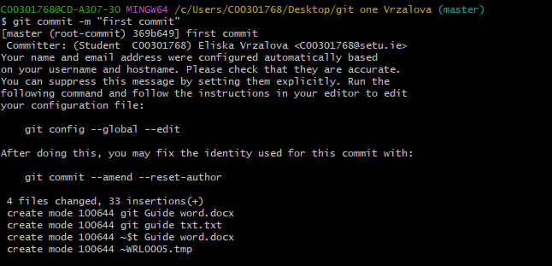Words after – m are comment, a label for this commit that needs to be in “ “ if it contains spaces.

Git remote

Command git remote is making your repository visible on github. Until now all of my git work was on my local one drive. Things that are remote are on Github server.

It allows me to save my work else where than on my local machine.

Remote= remote repository

Origin = the default name of the remote repository on Github

Master = the default name of the initial brach of a repository

Origin master = default branch of repository on github

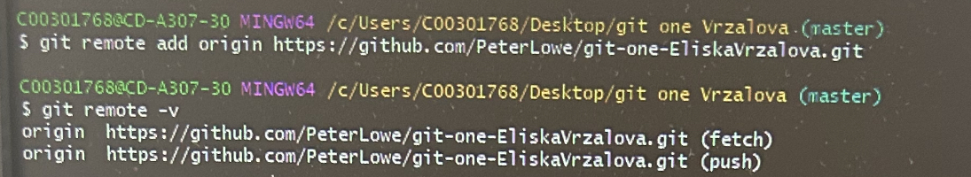

Git push

Updates the remote repository on Github.

We should push everytime we want to share the piece of work we have done with others. Good thing is also push small and often

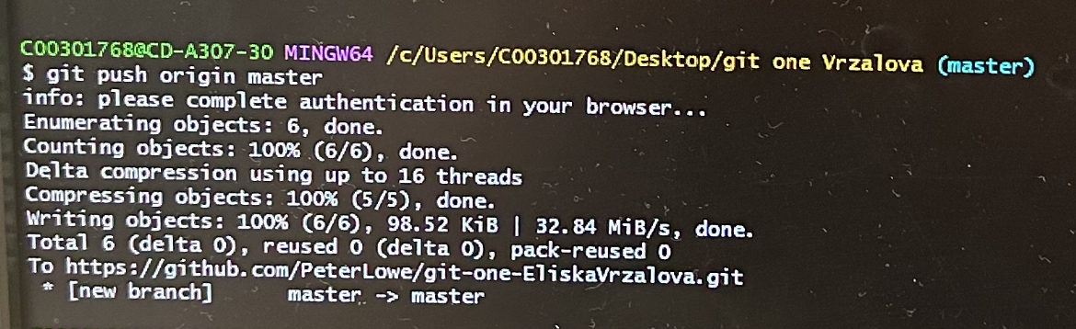

Git branch

Git branch command creates a new branch. We need to type in git branch and name of the new branch. I have named it newBranch. My command looked like : git branch newBranch.

Now I have to branched – master and newBranch

